HALASANA
“The PLOUGH POSE”
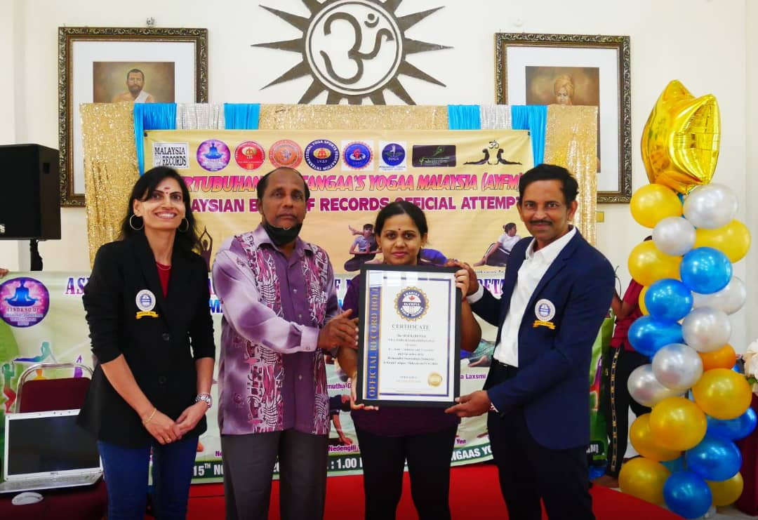
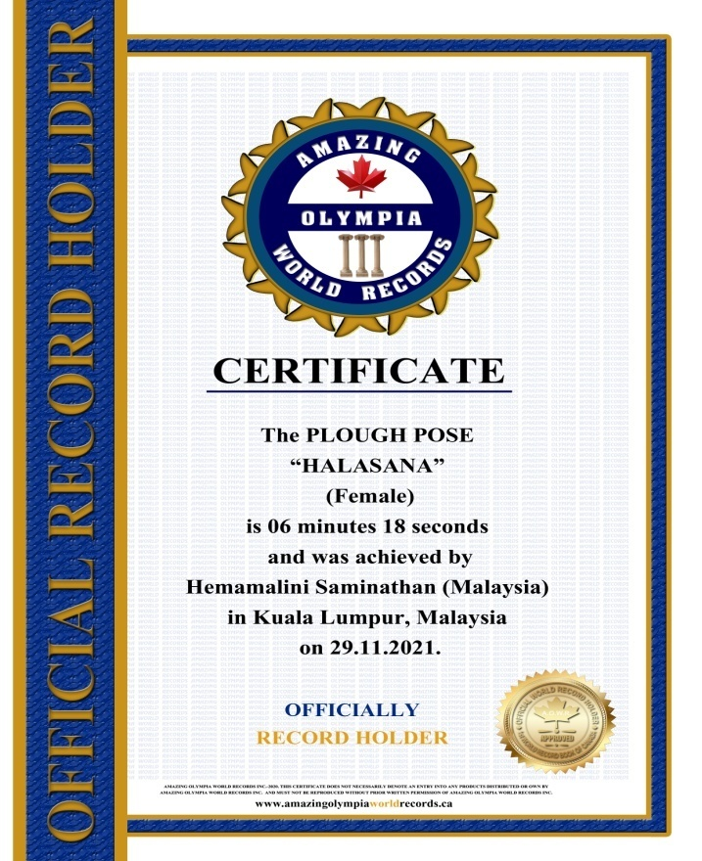
The PLOUGH POSE
HALASANA
(Female)

Currently has been measured for 06 minutes & 18 seconds and was achieved by Ms.Hemamalini Saminathan a Malaysian Citizen in Sungai Petani, Kedah, Malaysia on the date 29 Nov. 2021.

She has been received the title as:
OFFICIAL
“WORLD RECORD HOLDER”

